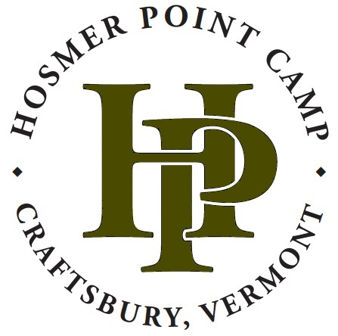
Hosmer Point Day Group
Parent Guide

Welcome! We are so excited to host your student’s school group at Hosmer Point! Thank you for giving permission for your student to join. This packet includes everything you need to know about your student’s experience at Hosmer Point. Don’t hesitate to reach out with further questions/concerns.

Hosmer Point Contact and Emergency Info
HP Office Phone: 802-586-2090
Craftsbury Outdoor Center Office Phone: 802-586-7767
hosmerpointinfo@gmail.com

If there is an emergency at home, please contact the Hosmer Point Office phone or your teacher’s phone number. We will find your student and make a plan as a group. If there is an emergency at camp, we will contact you immediately and make a plan as a group.

Overview of Trip. We like to start off each visit with a welcome and a quick overview of the expectations before we jump into whole-group warm-up games. From there, and depending on the requests from the teachers, the students may be split into smaller groups to rotate through activities on camp. Activities may include: canoeing/waterfront, farm/garden, low-ropes elements, archery, wilderness survival skills, etc. (To see more of our activity offerings, visit www.hosmerpoint.com). We have a lunch break in the middle of the day and then wrap up with a game/whole-group activity to end the end. We love to focus on team and community building while schools are at camp, as well as getting students outside in an accepting and technology-free environment.

Lunch. Check if your school will be bringing bagged lunches or providing the students with food from school. If the school is purchasing food from Hosmer Point, please inform your school if your student has any food allergies or dietary needs we should know about. If you have questions or concerns in regards to food, please reach out to our office manager, Carrie, at info@hosmerpoint.com.

Medications. Please inform the classroom teachers of any medications your students will need to take during their stay. All over-the-counter and prescription medicines are kept under lock and key in the health center and administered by a teacher. Students with EpiPens or inhalers are allowed to carry them during the day.

Health and Safety: In case of a medical concern, a teacher or chaperone will call the student’s parent or guardian as soon as possible to make a treatment plan. If a student needs professional care, they will be transported to Copley Hospital in Morrisville by a teacher or chaperone (or by ambulance if necessary). In addition, Hosmer Point staff are trained in wilderness first aid and may treat minor issues (such as small cuts and scrapes or sunburn) on-site. Please complete the health information and permission to treat form supplied by your school to ensure we can provide appropriate care to your child. Although ticks remain very rare on our campus, we recommend checking your student for ticks when they return home. You can learn more about tick-borne disease prevention at: http://www.healthvermont.gov/disease-control/tickborne-diseases

Behavior / Safety expectations. Please ensure your student is familiar with these expectations before arrival:
- The use of cell phones, iPods, computers, tablets, e-readers, and all other electronic devices is strictly prohibited while at camp.
- Under no circumstances may a student be in the possession of any of the following: alcohol, drugs, tobacco or marijuana products (including e-cigarettes and vapes), smoking paraphernalia (such as vaping jules), fireworks, matches, lighters, or weapons.
- Any vandalism or theft of camp property will not be tolerated. Students will be required to correct any damage and/or will be charged for repairs. This includes littering from lunch.
- Any harassment, hazing, or teasing with the intent to belittle, scare, offend or harm is unacceptable at camp.
- The use of vulgar language will not be tolerated.
- Students may not leave camp grounds without Director, Teacher, or Parent permission.
- All visitors must wear lifejackets while on boats. Students will be asked to use the buddy system while swimming.
- Students may not enter off-limit areas of camp, unless instructed by a Hosmer Point employee. Off-limit areas include, but are not limited to: the waterfront, cabin sections, maintenance buildings, kitchen, any low-ropes elements, and farm/garden.
Breaking any of the rules above may result in disciplinary action and/or dismissal from the trip (at the discretion of the camp directors and teachers). We hope and expect students to participate in all activities with an open mind and positive attitude!

Pre-Trip Checklist
- Complete waiver and health forms and hand in to school
- Review behavior and safety expectations with your student
- Inform school of any medications your student will need to bring
- Inform school of any food allergies or dietary needs

Packing List

Clothing
- Wool or synthetic fleece top or sweatshirt
- Pair of sturdy footwear (sneakers and/or hiking boots)
- Rain jacket
- Coat, hat, gloves, and thermal underwear if weather is cold (due to elevation, the weather at Hosmer Point will likely be colder than at your home)
Waterfront
- 1 bathing suit (camp appropriate)
- 1 beach towel
- 1 pair of wet shoes or sandals with a captured heel
Other
- Water bottle (labeled with your name)
- Bagged lunch (unless provided by your school)

Optional
- Small day pack for water bottle and extra gear
- Mosquito/Tick repellant (non-aerosol, please)
- Sun screen
- Hat with visor
Items to leave at home
- Money
- Jewelry
- Expensive belongings
- Cell phones, iPods, iPads, and other electronic games/devices
- Lighters / matches
- Pocket knives, guns, and other weapons
HP is not responsible for damage to or theft of any items! Most camp activities take place outdoors, rain or shine. You will get dirty at camp, so do not bring your favorite outfits.

